



Student Name: SHUBHAM
Roll No. 2301730100
Course Code- ENCS351 Course Name – Operating system
Program Name: B.Tech. CSE- (AI/ML)
GitHub Repository Link :
https://github.com/shubham055555/OS-ASSIGNMENT.git

Problem Title:
System Calls, VM Detection, and File System Operations using Python

Problem Statement:
Operating systems expose low-level interfaces like system calls to allow interaction between user programs and the OS kernel. This lab simulates system-level OS tasks such as process creation (using fork and exec), file and memory operations, VM detection, and CPU scheduling. Learners will develop shell, C, and Python scripts to model batch execution, inter-process communication, and basic file system behaviors.

Tools/Technology Used:
Python 3.x
Linux OS (for system-level calls) OS, platform, subprocess modules
Bash shell, C programming (for fork/exec/wait)

Learning Objectives:
- Execute Python scripts in a batch processing environment
- Simulate system startup and process termination logging
- Demonstrate use of system calls (fork(), exec(), wait(), pipe())
- Detect virtual machine environments programmatically
- Simulate basic file system operations using Python

Sub Tasks

Task 1: Batch Processing Simulation (Python)
Write a Python script to execute multiple .py files sequentially, mimicking batch processing.
import subprocess
scripts = ['script1.py', 'script2.py', 'script3.py'] for script in scripts:
print(f"Executing {script}...") subprocess.call(['python3', script])

code :
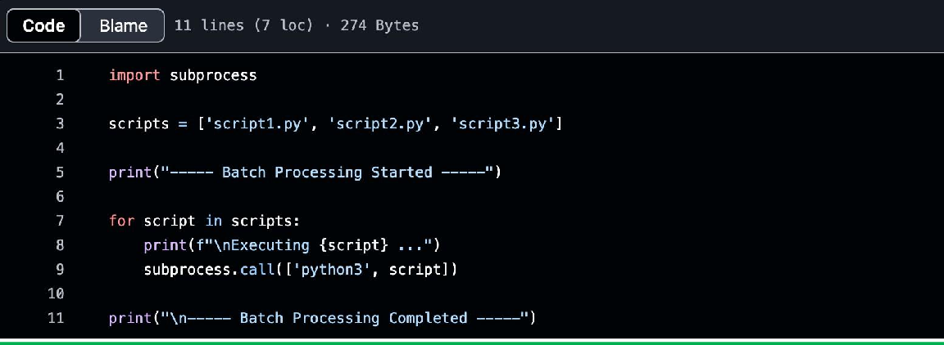

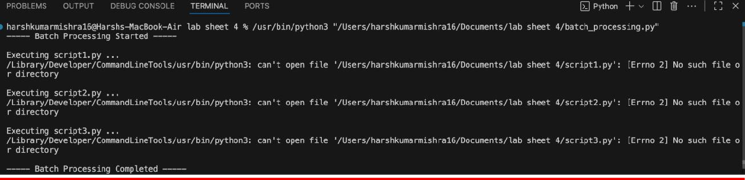
Output :

Task 2: System Startup and Logging
Simulate system startup using Python by creating multiple processes and logging their start and end into a log file.
import multiprocessing import logging import time logging.basicConfig(filename='system_log.txt', level=logging.INFO, format='%(asctime)s - %(processName)s - %(message)s') def process_task(name):
logging.info(f"{name} started") time.sleep(2) logging.info(f"{name} terminated") if name ==

' main ': print("System Booting...") p1 = multiprocessing.Process(target=proces s_task, args=("Process-1",)) p2 = multiprocessing.Process(target=proces s_task, args=("Process-2",))
p1.start() p2.start()
p1.join() p2.join() print("System Shutdown.")

code :

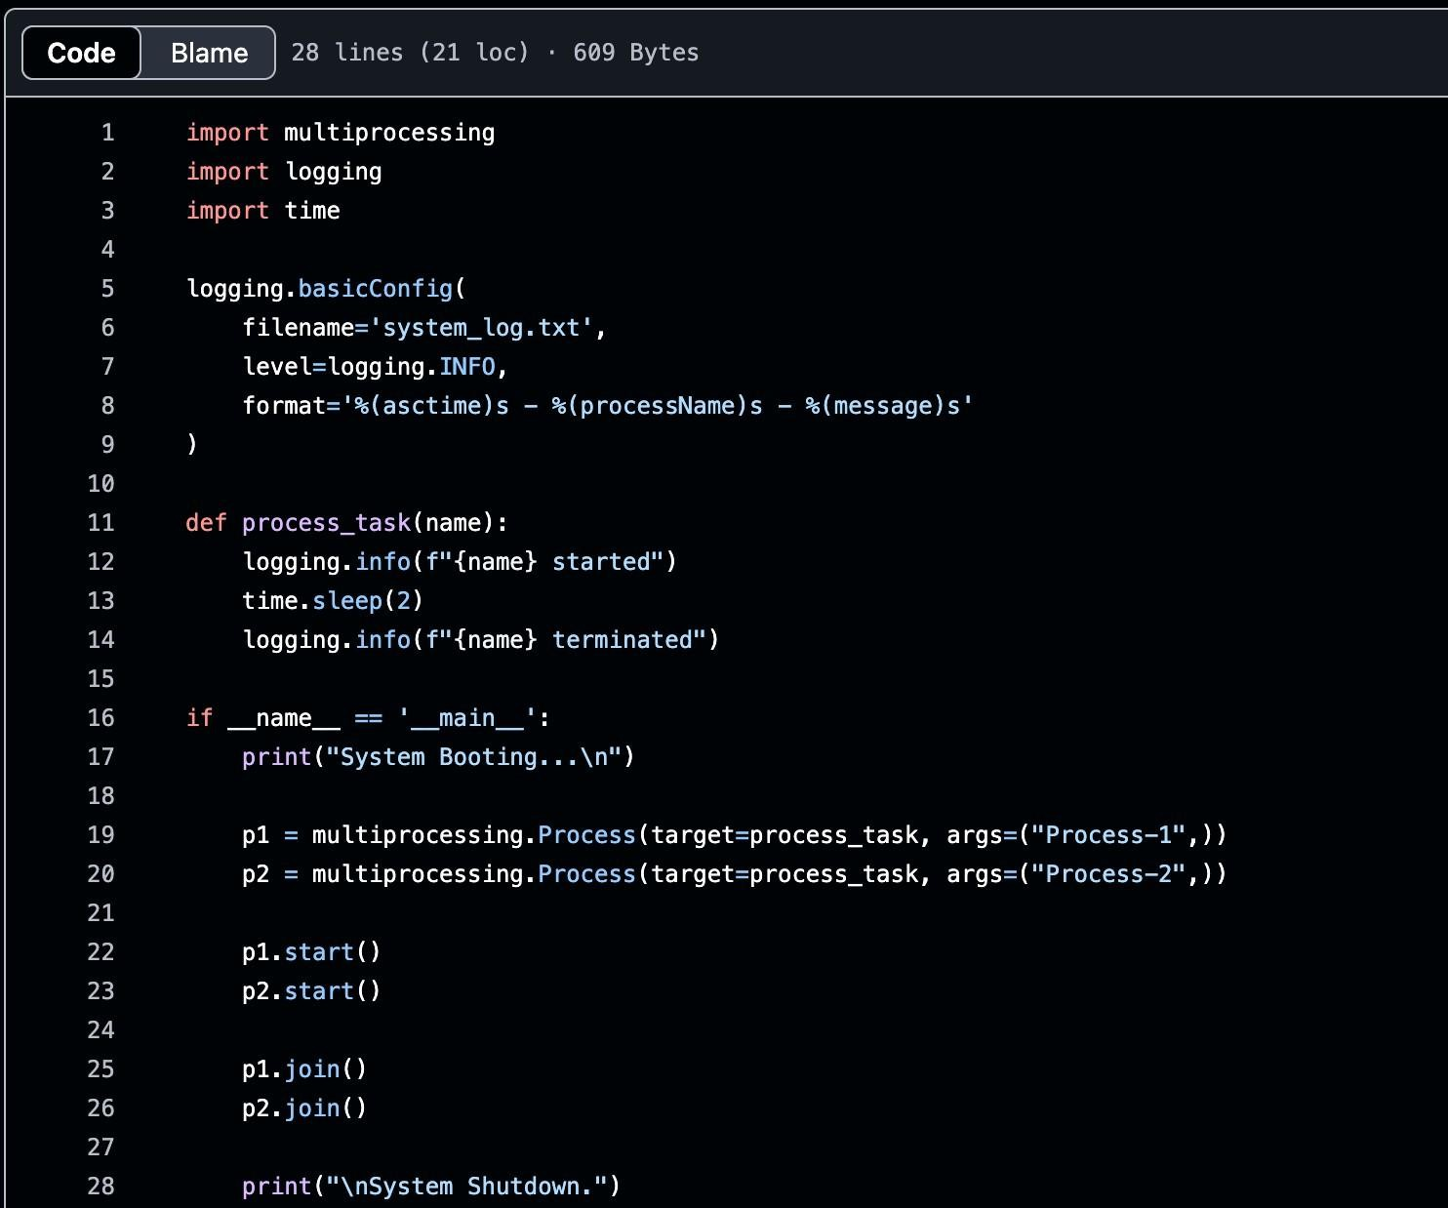

Output :

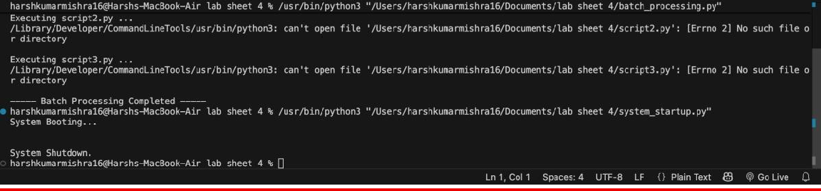
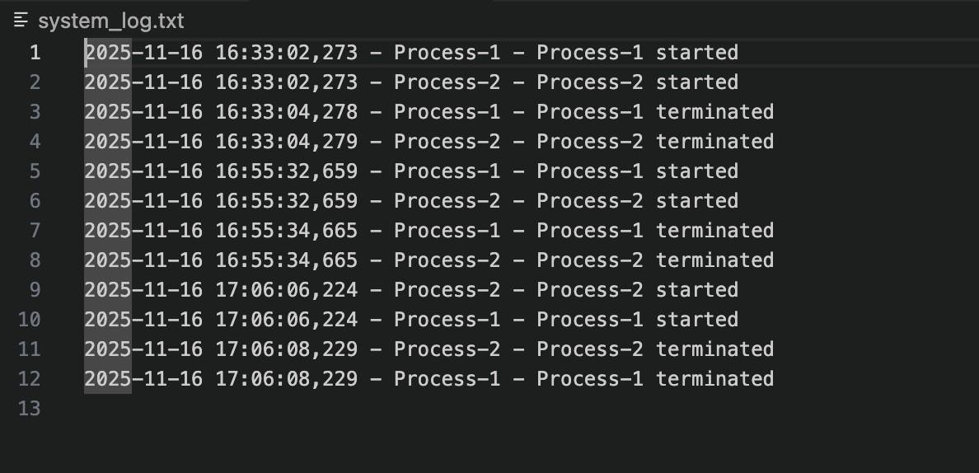

Task 3: System Calls and IPC (Python - fork, exec, pipe)
Use system calls (fork(), exec(), wait()) and implement basic Inter-Process Communication using pipes in C or Python.
import os r, w
= os.pipe() pid
= os.fork() if pid > 0:
os.close(r)
os.write(w, b"Hello from parent") os.close(w) os.wait()
else:

os.close(w) message = os.read(r, 1024)
print("Child received:", message.decode()) os.close(r)

code :

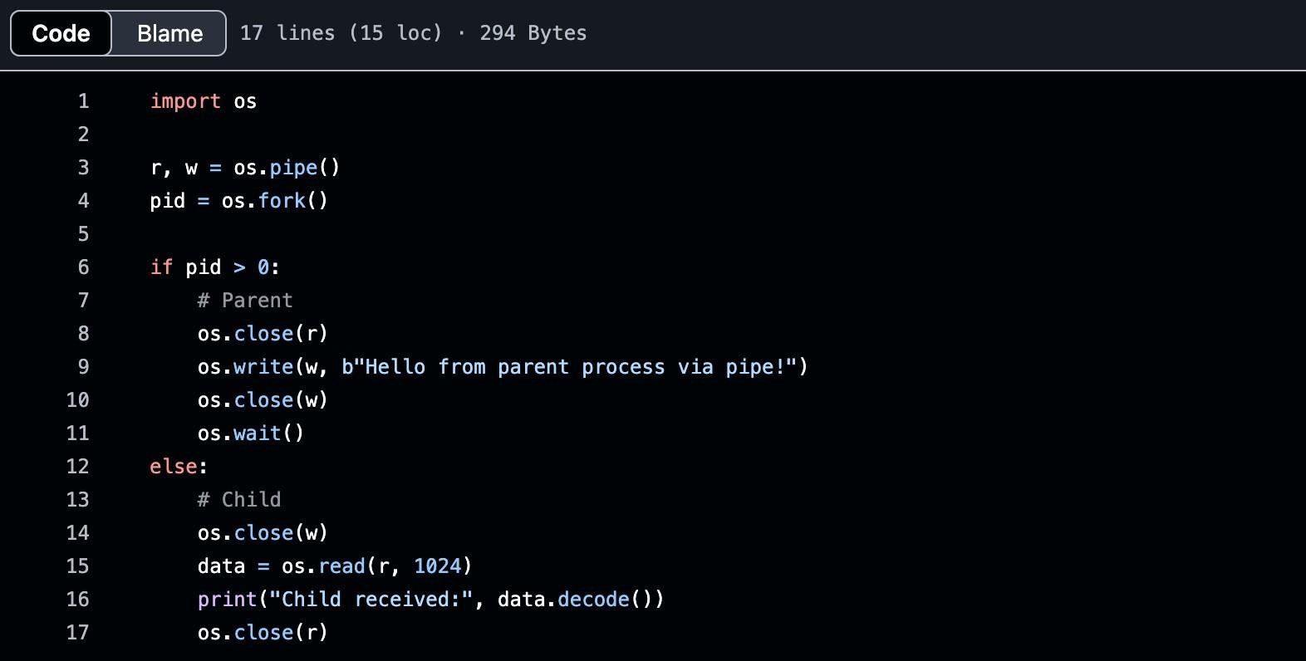

Output :

Task 4: VM Detection and Shell Interaction
Create a shell script to print system details and a Python script to detect if the system is running inside a virtual machine.
#!/bin/bash

echo "Kernel Version:" uname -r echo "User:" whoami
echo "Hardware Info:" lscpu | grep 'Virtualization'

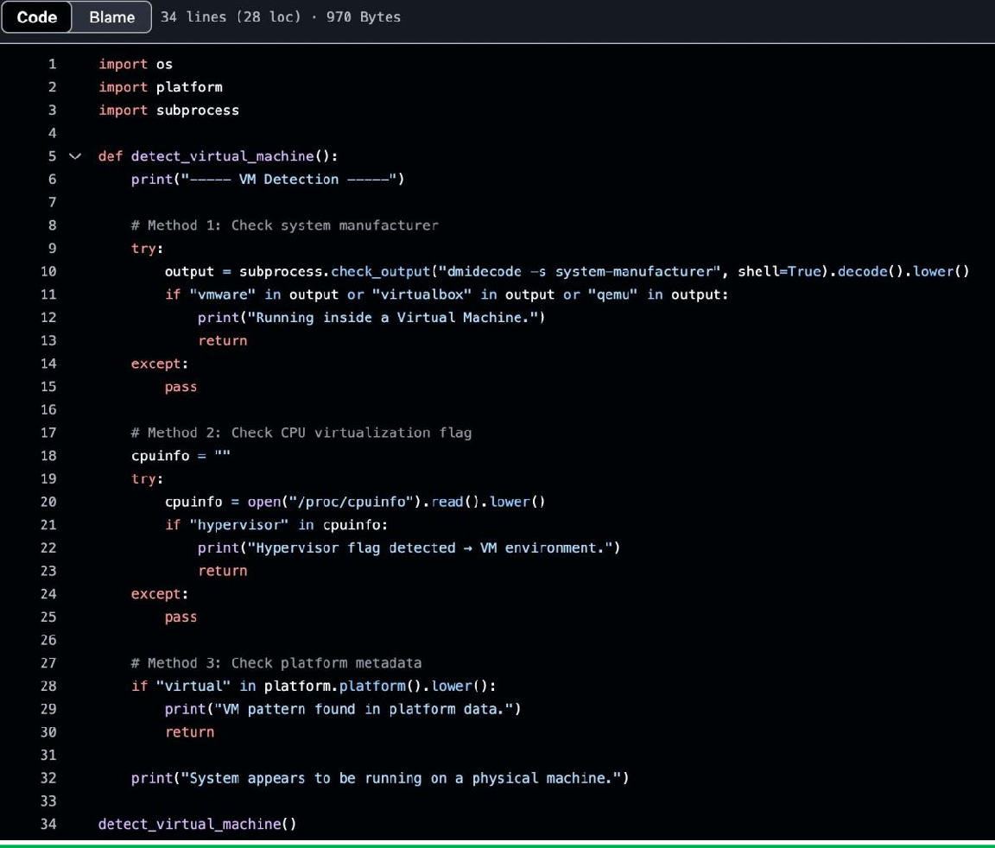
code :

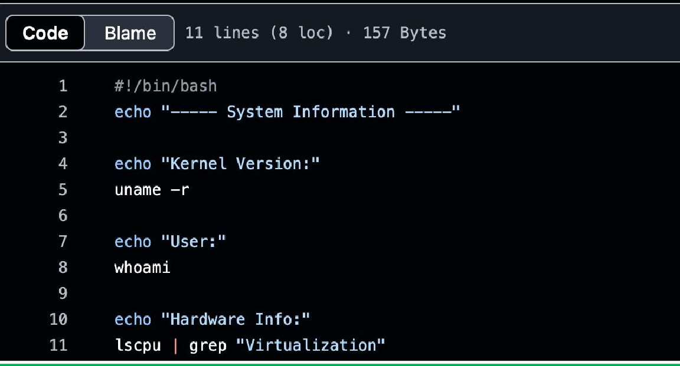

Task 5: CPU Scheduling Algorithms
Implement FCFS, SJF, Round Robin, and Priority Scheduling algorithms in Python to calculate WT and TAT.

Use existing Round Robin, FCFS, SJF, Priority scheduling Python codes from Lab 3)

code :

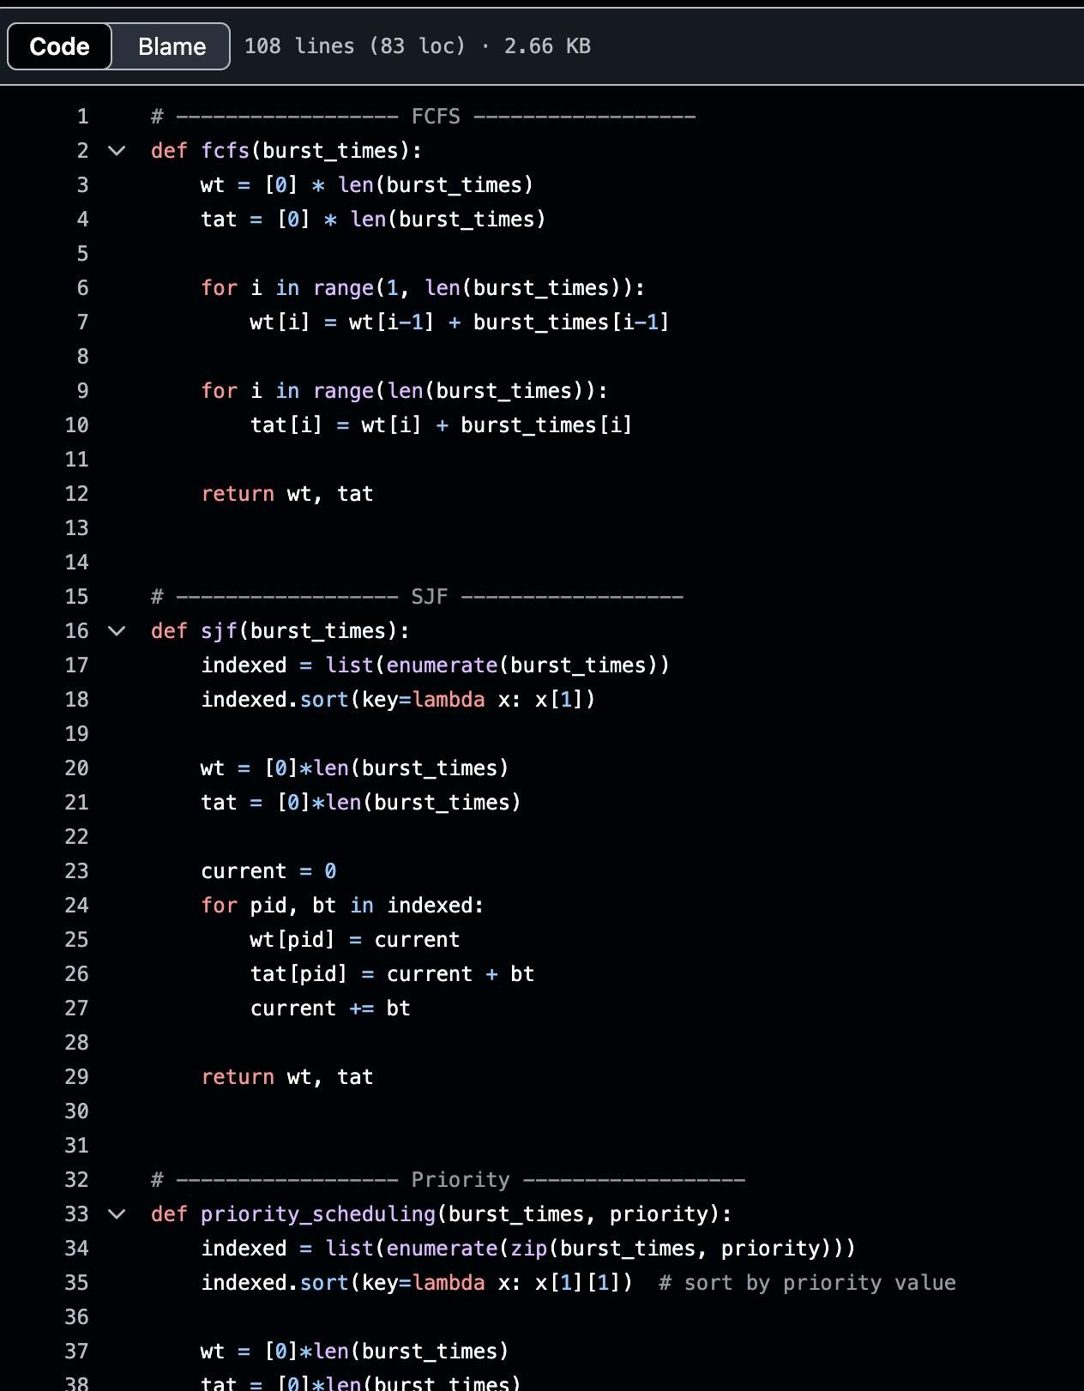

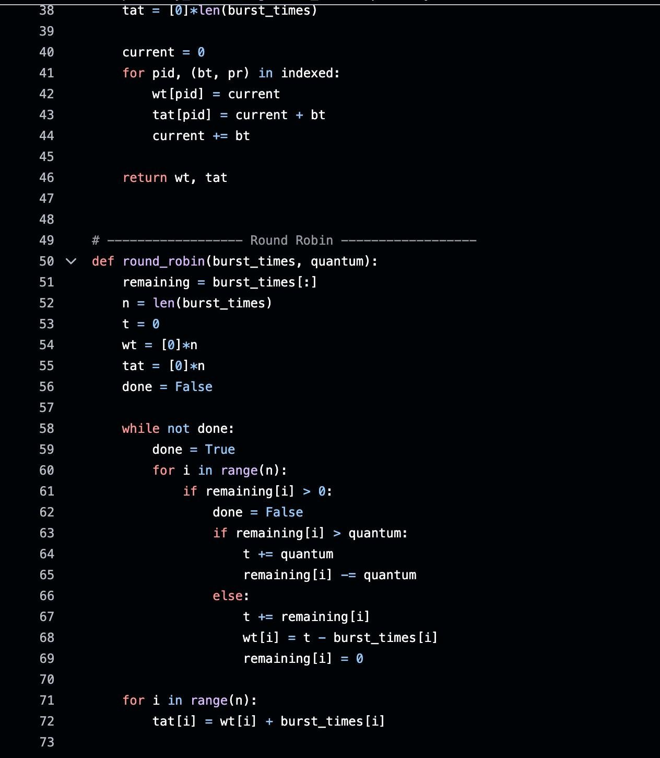

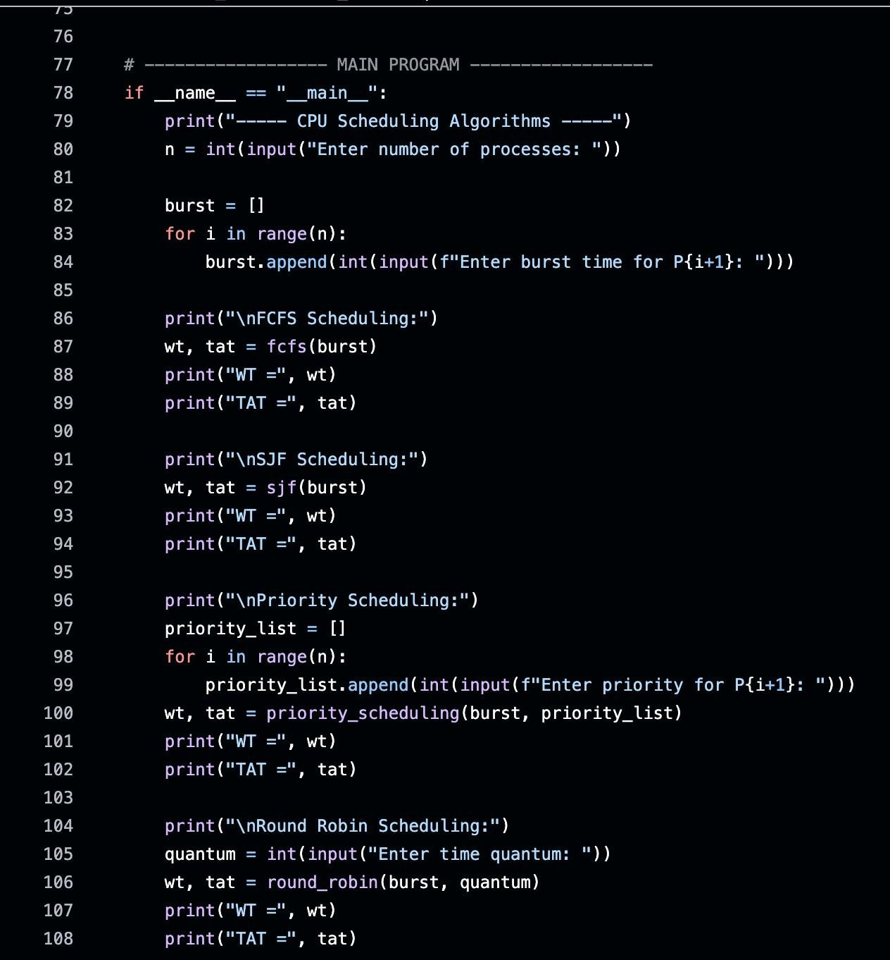

Output :
